**HTML DOM EVENTS**

There are 3 ways to add events in your page:

1. **Inline way:**

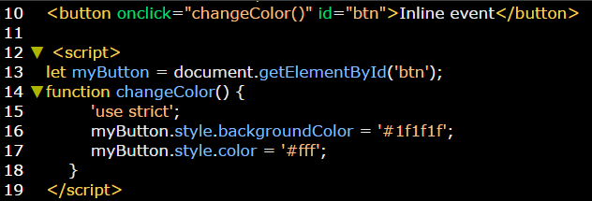

1. **Second way:**

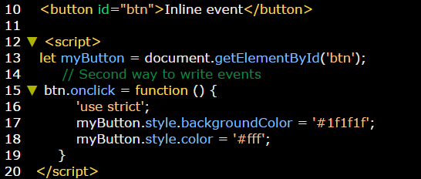

1. **Third way:**

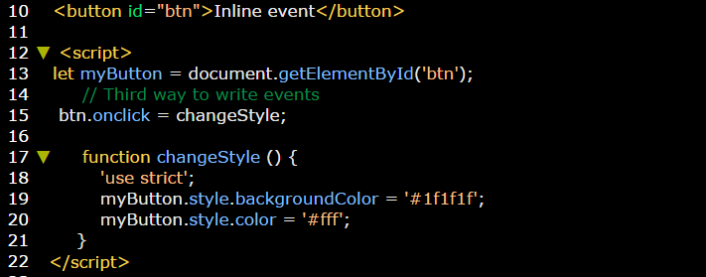

JS events are:

|  |  |
| --- | --- |
| **Event** | **Description** |
| **Element.onload** | **Applying** some event after loading the page. {it usually uses on making loading pages before beginning the website} |
| **Element.onscroll** | **Applying** some event on scrolling the page. {it usually uses on making go to top button, appearing sections on scrolling } |
| **Element.onreszie** | **Applying** some event on resize the page. {it usually uses on making go to top button, appearing sections on scrolling } |
| **Input-element.onfocus** | **Applying** some event on focusing on specific element. {showing alert message } |
| **Input-element.onblur** | **Applying** some event on blurring out specific element. |
| **Input-element.onsubmit** | **Applying** some event on pressing submit button. |
| **element.onclick** | **Applying** some event on clicking the element. |
| **element.ondblclick** | **Applying** some event on double clicking the element. |
| **element.onmouseover** | **Applying** some event on hovering the element. |
| **element.oncontextmenu** | **Applying** some event on pressing right click (on mouse) over the element. |
| **element.onmouseenter** | **Applying** some event when the mouse pointer is moved onto an element. |
| **element.onmouseleave** | **Applying** some event when the mouse pointer is moved away of an element. |
| **element.onkeyup** | **Applying** some event when the user releases a key (on the keyboard). |

Reference: <http://help.dottoro.com/larrqqck.php>

**Example:** on onload event.

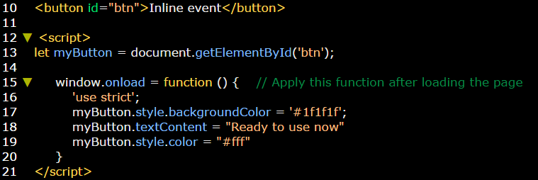

**Example:** on onscroll event.

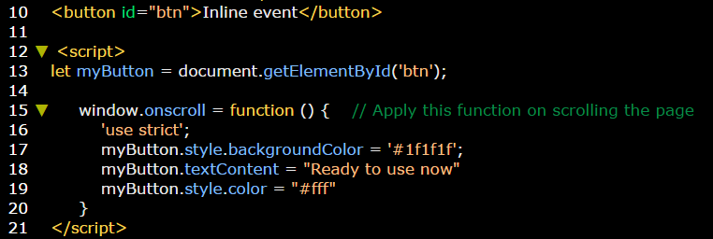

**Example:** on onresize event.

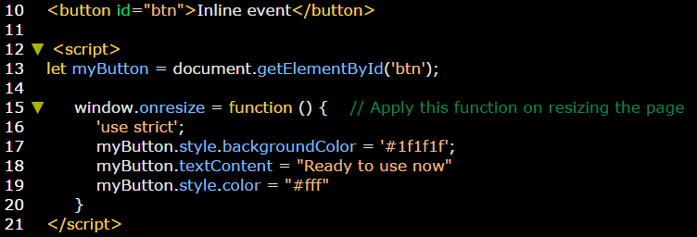

**Example:** on focusing and blurring event.

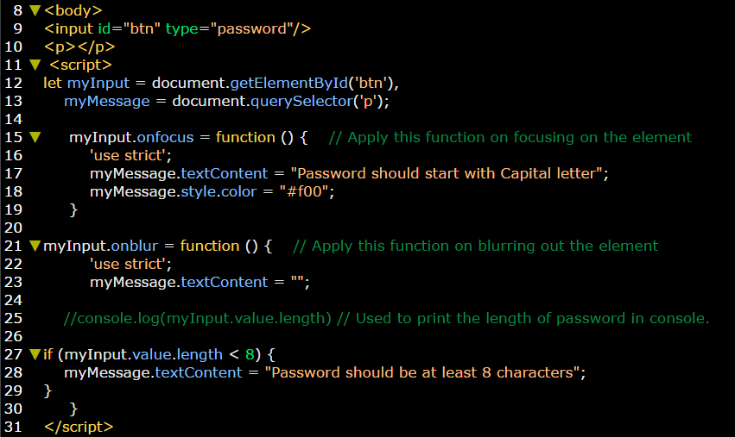

**Example:** on submit.

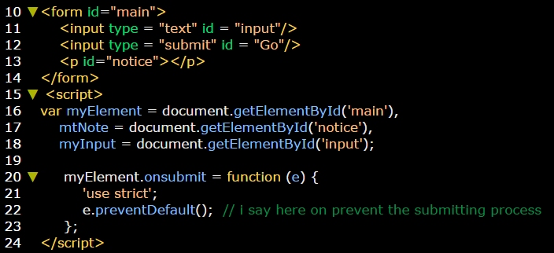

**Example:** onclick event

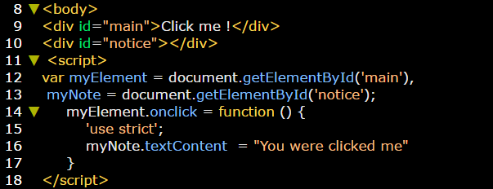

**Example:** on double click event.

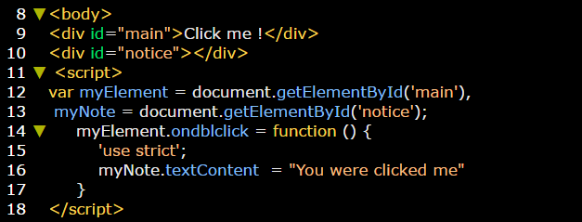

**Example:** on mouse over event.

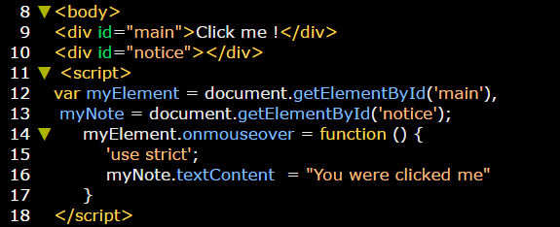

**Example:** on contextmenu event.

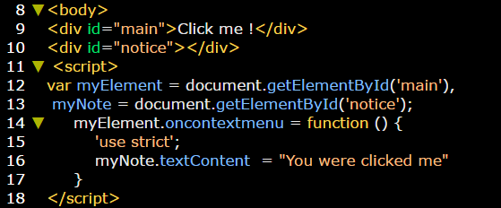

**Example:** onmouseenter event.

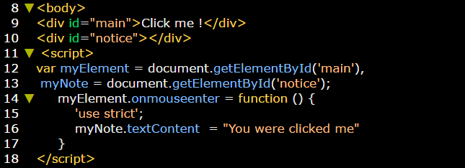

**Example:** onmouseleave event.

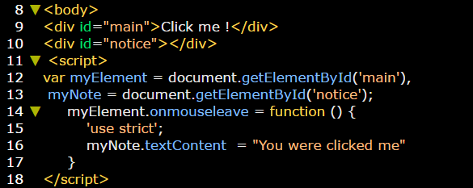

**Example:** onkeyup event.

